INSTRUCTIONS TO AUTHORS FOR THE PREPARATION OF PAPERS FOR THE NINTH EUROPEAN CONFERENCE ON SPACE DEBRIS

Principal Author Name(1), Co-Author Name(1), Co-Author Name(2)

(1) Affiliation, Complete mailing address (including country), Email:

(2) Affiliation, Complete mailing address (including country), Email:

ABSTRACT

The Proceedings of the Symposium will be published by ESA via a website.

Authors must deliver their full papers by 25 March 2025 as electronic ‘PDF’ by uploading it to the conference portal; details are given in Sections 11 and 12.

Please read the following instructions for the preparation of your paper in accordance with ESA’s standards for conference proceedings. Each submission should resemble these instruction sheets in format and style. Start with a concise abstract (limited to 15 lines or 150 words) that summarises the contents of the paper.

# GENERAL SPECIFICATIONS

The paper must be prepared in this two-column format and **should not exceed 15 pages.**

This sheet has been typeset in accordance with the Word style templates to be followed.

# PAGE LAYOUT

* Paper format: standard A4 (297x210 mm),
* two-column format (8 cm each column),
* margins: top 25 mm, left and right 20 mm, bottom 37 mm,
* fully justified.

Font:

* Text: Times New Roman
* Variables: Times New Roman italic
* Symbols: True Type Symbol font

Type Size:

* Paper title: 12 pt bold (**TITLE**)
* Author(s): 10 pt bold (**Author**)
* Affiliation(s): 10 pt italic (*Affiliation*)
* Normal text: 10 pt (regular text)
* Captions: 10 pt italic (*Figure)*
* Text in tables: 9 pt
* Symbols: 10 pt (Ω α ϕ)
* Sub/superscript via Word (xy)

**For LaTeX users:** a set of macros is available via the author instructions at the conference webpage, too.

# HEADERS AND FOOTERS

Both the header and the footer should be left empty. Do not add page numbers.

# TITLE AND AUTHOR AFFILIATION

The paper title, author(s) name(s), affiliation, complete mailing address and email should be centred at the top of the first page using the fonts and type sizes indicated above. If there are several authors, the complete affiliation should be given for each of them using superscripts(1) in the authors(2) list to refer to them.

# HEADINGS

Use the decimal system in Arabic figures for the numbering of headings and subheadings. Major (or section) headings are to be in capitals and bold.

## Subheadings

Subheadings or subsection headings are to be in lower case with initial capitals and bold font. They should be flush with the left-hand margin, on a separate line.

# EQUATIONS

Equations are to be numbered consecutively throughout the paper. Each equation number must be unique. Equations should be centred, with the equation number in parentheses flush with the right-hand margin of the column. Leave a blank line before and after equations. Always refer to equations by number, as Eq. 1 or Eqs. 3-6, not as ‘above’ or ‘below’.

|  |  |  |
| --- | --- | --- |
|  | $$T_{S}=\frac{T_{b}}{1+\left(λ{T_{b}}/α\right)\ln{ε}}$$ | (1) |

# FIGURES AND TABLES

Figures and tables can extend over two columns if required. Figure captions should be centred below the figures; table captions should be centred above the tables. Use full word ‘Figure 1’ or ‘Table 1’ in the caption. Use the abbreviation “Fig. 1” or “Tab. 1” in the text (even at the beginning of a sentence).

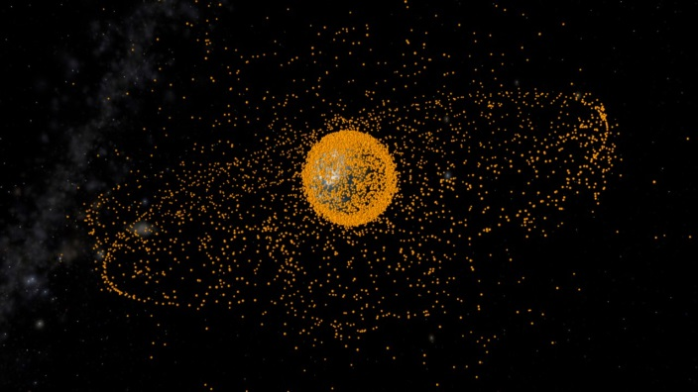

Figure 1. Space Debris 2009

# ABBREVIATIONS AND ACRONYMS

Define abbreviations and acronyms the first time they are used in the text, even after they have been defined in the abstract. Do not use abbreviations in the title unless they are unavoidable.

# REFERENCES

Number citations consecutively in square brackets [1]. Refer simply to the reference number, as in [3]. Do not use ‘Ref. [3]’ or ‘reference [3]’ except at the beginning of a sentence: ‘Reference [3] was the first …’. The title of the book or of the journal should be in italic script. Further information is available in “How to reference a publication” at:   
<http://www.esa.int/esapub/conference/references.pdf>

## Sample References

1. Smith, J.M., Adams, B.A. & Wilson, A. (2002). The Future for Asteroid Exploration. *Planet. Space Sci.* **285**(11), 123-126.
2. Johnson, A.B. & Radice, X.T. (2002). *Comets for Beginners*, Cambridge University Press, Cambridge, UK, pp103-106.
3. Svalgaard, L. & LeSager, P. (2003). What Heliosesimology Teaches us About the Sun. In *Proc. 4th. ISCS ‘Solar Variability as an Input to the Earth’s Environment’* (Eds. H. Lacoste & H. Xerxes), ESA SP-535 (CD-ROM), ESA Publications Division, European Space Agency, Noordwijk, The Netherlands.

# Use of Artificial Intelligence (AI) by authors

We adopt an approach that is aligned with the [AIAA Ethical Standards for Publication](https://www.aiaa.org/publications/Publish-with-AIAA/Ethical-Standards-for-Publication-of-Aeronautics-and-Astronautics-Research#2-ethical-standards-for-aiaa-journals-and-books), i.e. we ask to respect the following obligations of authors:

As usual, each author is fully responsible and accountable for the content of the entire manuscript, including the accuracy, integrity, and completeness of the manuscript, citation of previous work, obtaining copyright approval, and potential issues of plagiarism.

**If authors use any type of AI technology** in the writing process, we ask you to observe the following rules (note that the term author refers to all contributing authors of the manuscript under consideration):

Writing:

* AI should be used primarily to improve readability, grammar, and language in the work.
* Authors may not list AI or AI-assisted technologies as a co-author.
* Authors may not cite AI engines as an original source.
* When authors use AI in the writing process, they must disclose the use of AI technologies used in the preparation of the manuscript as part of the manuscript (disclosures exclude the use of spelling and grammar checkers that are included in word processing software).

Creation or editing of illustrations, graphics, and photographs:

* AI can be used to construct or modify illustrations, figures or graphics to improve clarity and the communication of concepts.
* AI can be used to modify a photograph to improve the clarity or particular features of interest. However, AI shall not be used to generate false or misleading photographs, such as adding objects or images of individuals.
* Regardless of how an illustration, figure, graphic, or photograph is constructed, the authors are fully responsible for appropriate citation to previous work, obtaining needed copyright permission, and potential issues of plagiarism.
* Note that citation and copyright protection may apply even if a previously published figure has been altered.
* When authors use AI for an illustration, figure, graphic, or photograph, they must disclose the use of AI technologies as part of the manuscript.

# PDF PREPARATION

In order to allow reasonable quality printing, please avoid excessive compression when making your PDF file. Generally, image resolutions should be 600 dpi.

**VERY IMPORTANT: EMBED ALL FONTS** and ensure that the PDF’s security setting is on ‘NO SECURITY’. The maximum allowed file size is 15 MB.

# SUBMITTING THE PAPER

Papers must be delivered by 25 March 2025 at the latest by uploading it to the conference portal. Please note that you are allowed to re-upload your paper until the expiration of the deadline.